Tree: https://www.geeksforgeeks.org/introduction-to-tree-data-structure/

Types of tree: https://www.geeksforgeeks.org/types-of-trees-in-data-structures/

Binary Tree:
https://www.geeksforgeeks.org/binary-tree-data-structure/

Problem: https://www.geeksforgeeks.org/problems/height-of-binary-tree/1
C++
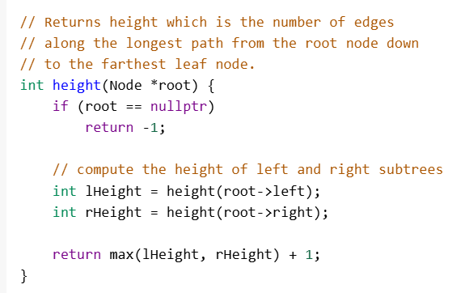
Java:
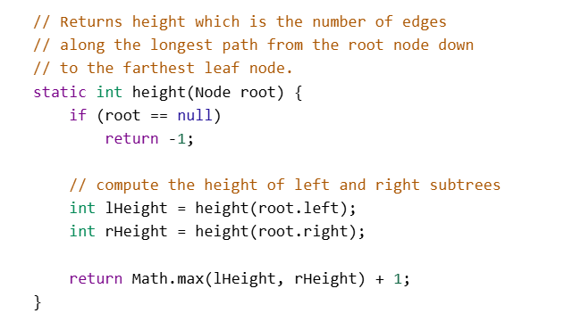
Python:
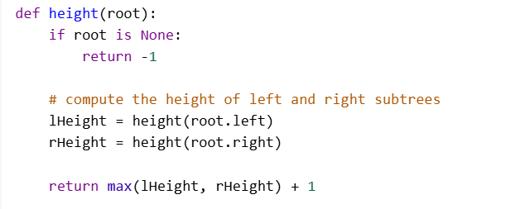

Problem:https://www.geeksforgeeks.org/problems/inorder-traversal/1
C++
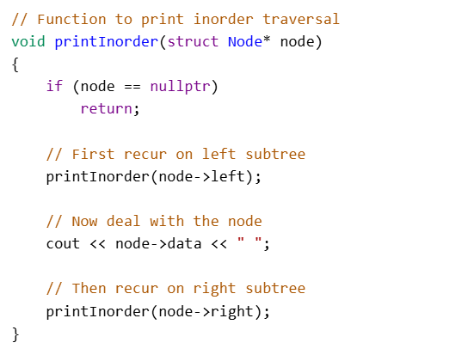

Java:
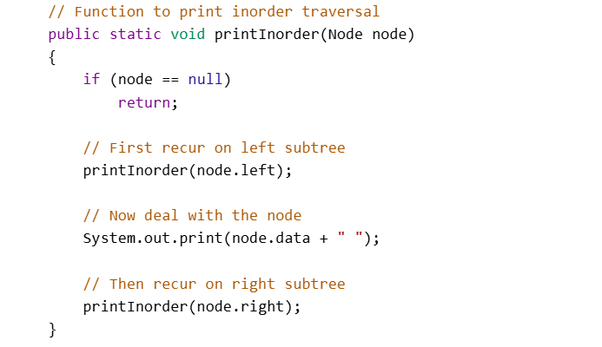Python:
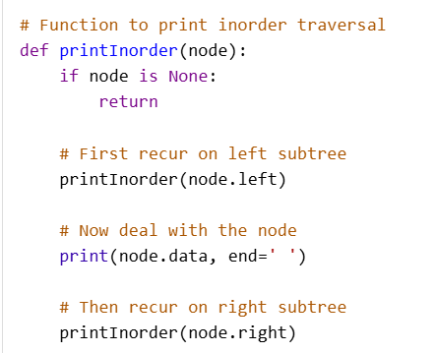

Problem: https://www.geeksforgeeks.org/problems/preorder-traversal/1
C++
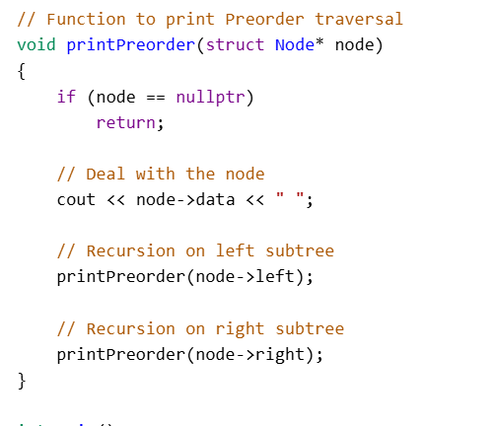
Java:
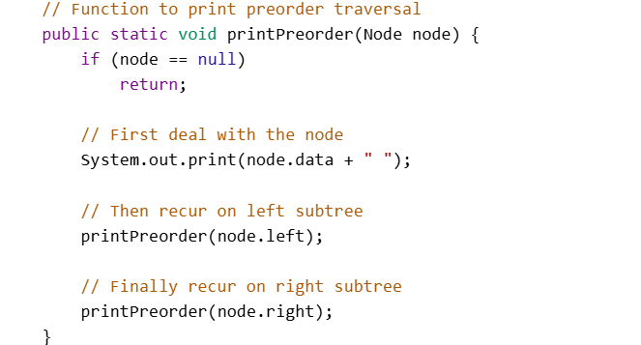
Python:
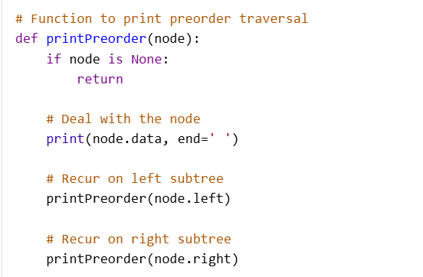

Problem:
https://www.geeksforgeeks.org/problems/postorder-traversal/1
C++
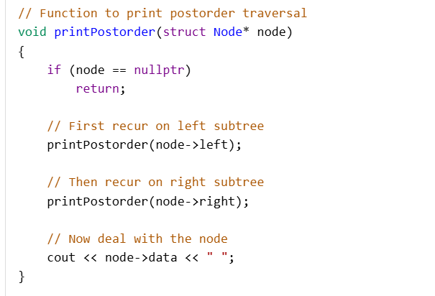
Java:
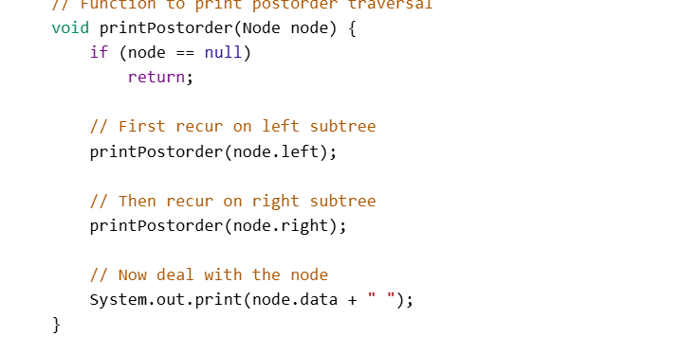
Python:
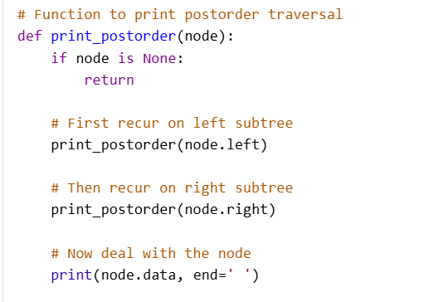

Problem: https://www.geeksforgeeks.org/problems/check-for-balanced-tree/1
C++
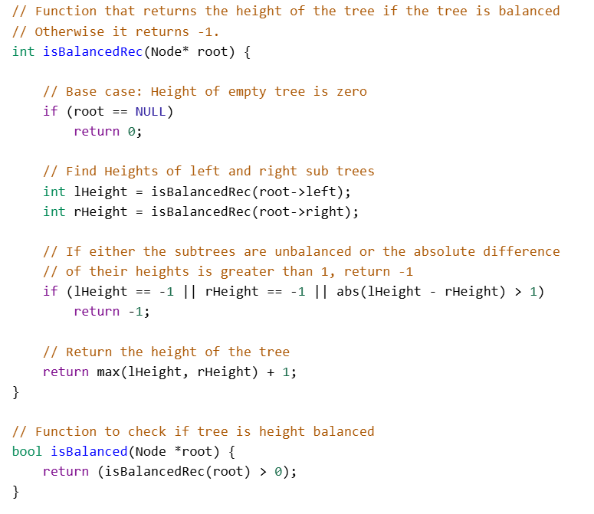

Java:
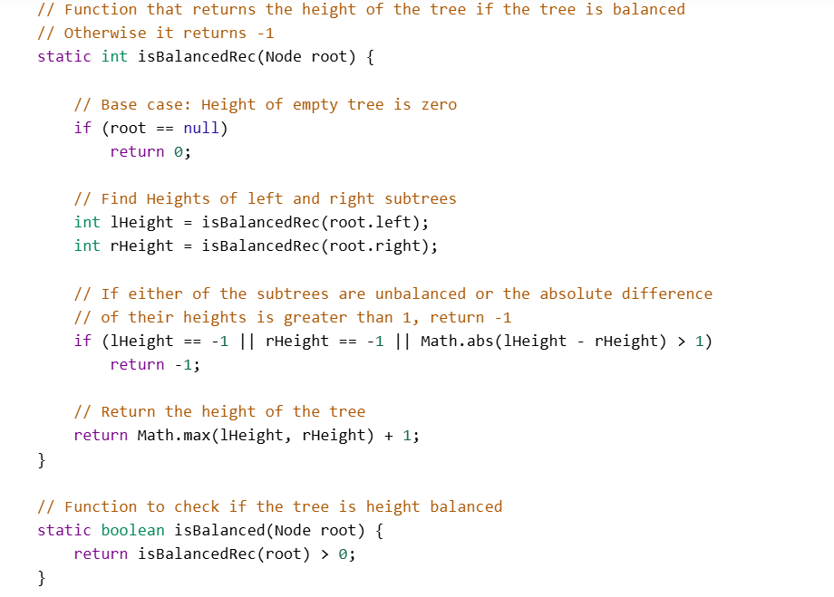

Python:
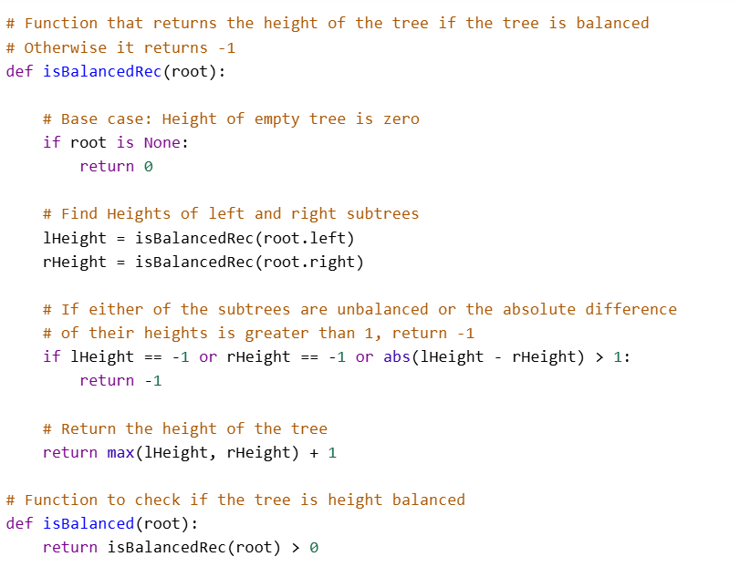

Problem: https://www.geeksforgeeks.org/problems/diameter-of-binary-tree/1
Java:
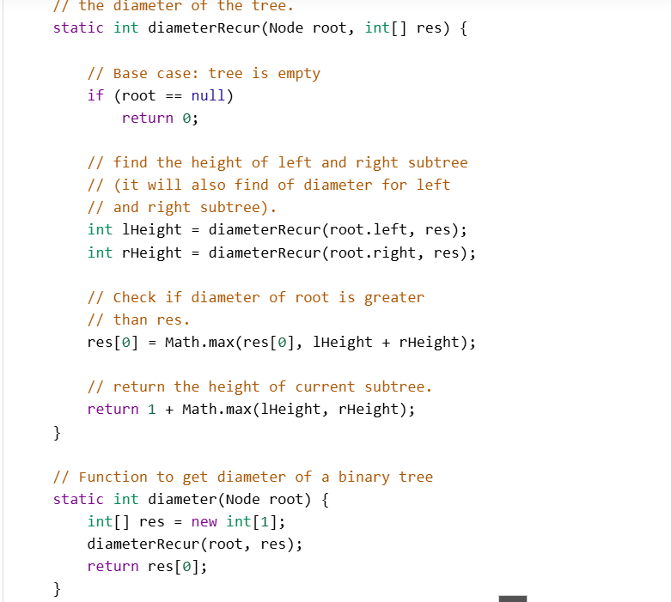

C++
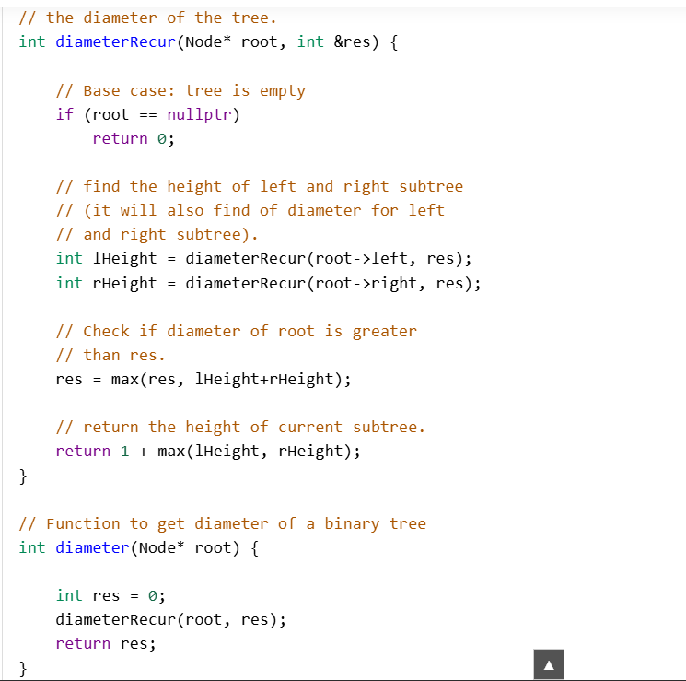

Java:
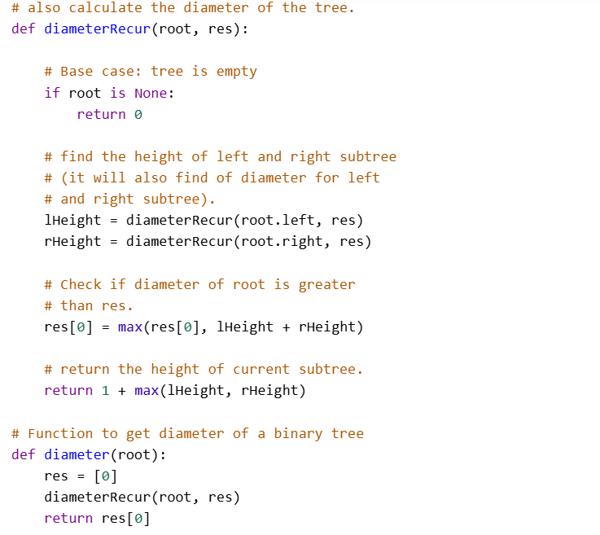

Problem: https://www.geeksforgeeks.org/problems/lowest-common-ancestor-in-a-binary-tree/1
C++
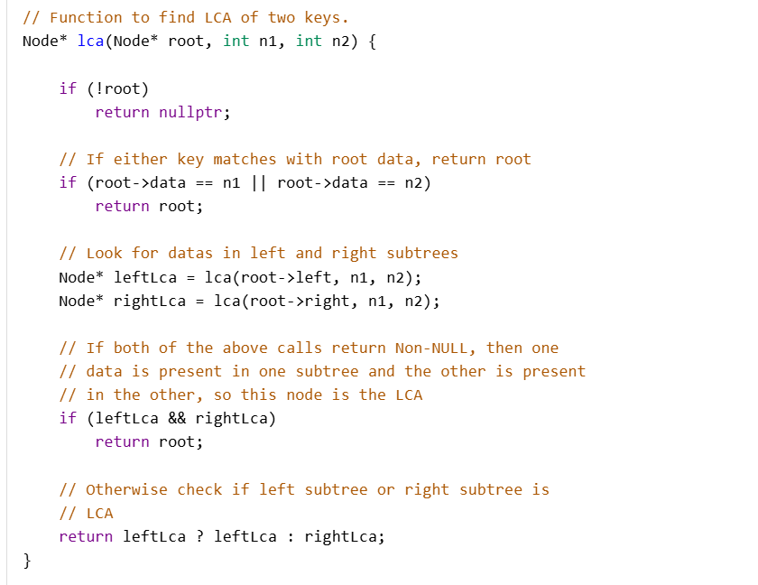
Java:
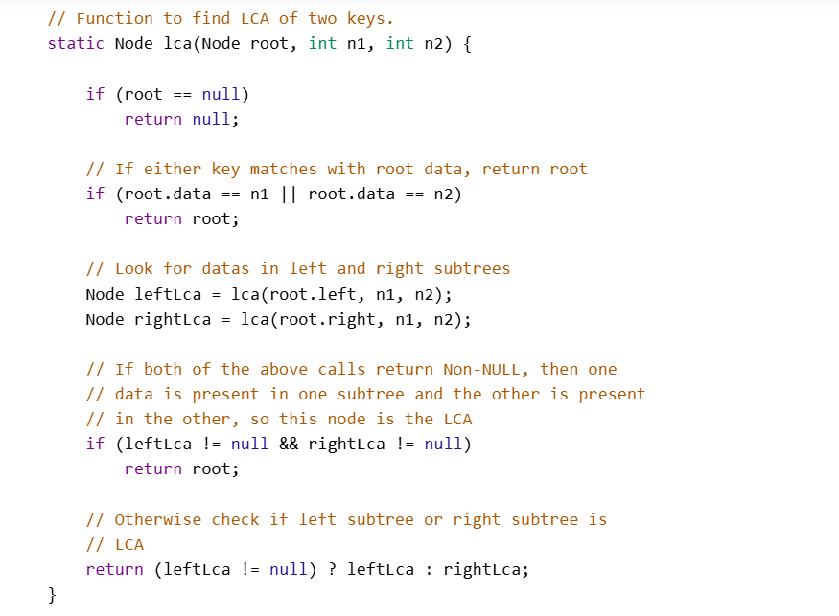

Python:
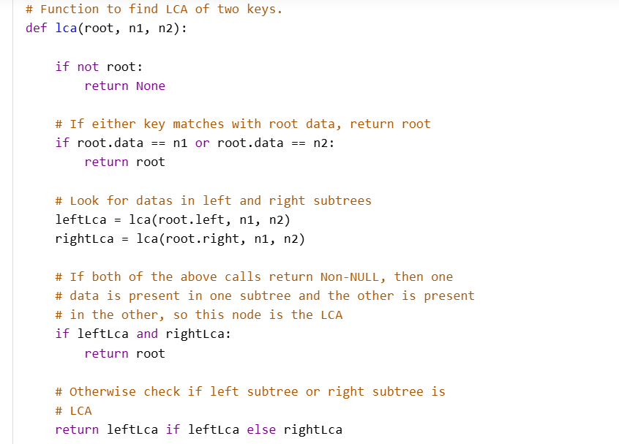

Problem: https://www.geeksforgeeks.org/problems/level-order-traversal/1

C++
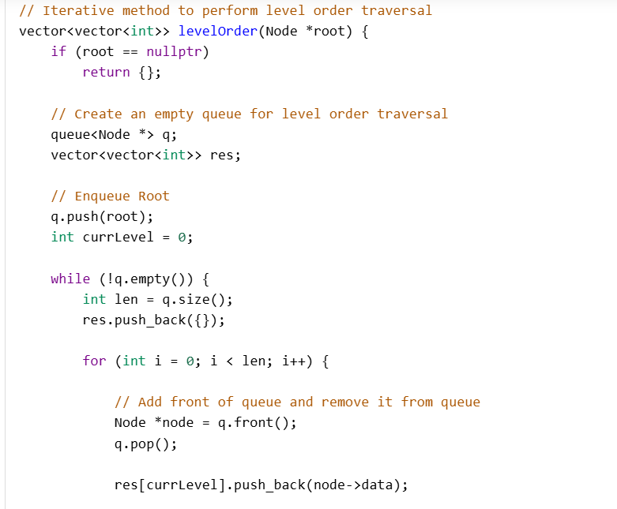
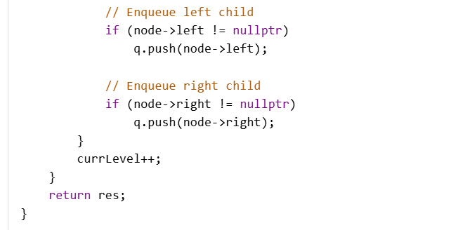

Java:
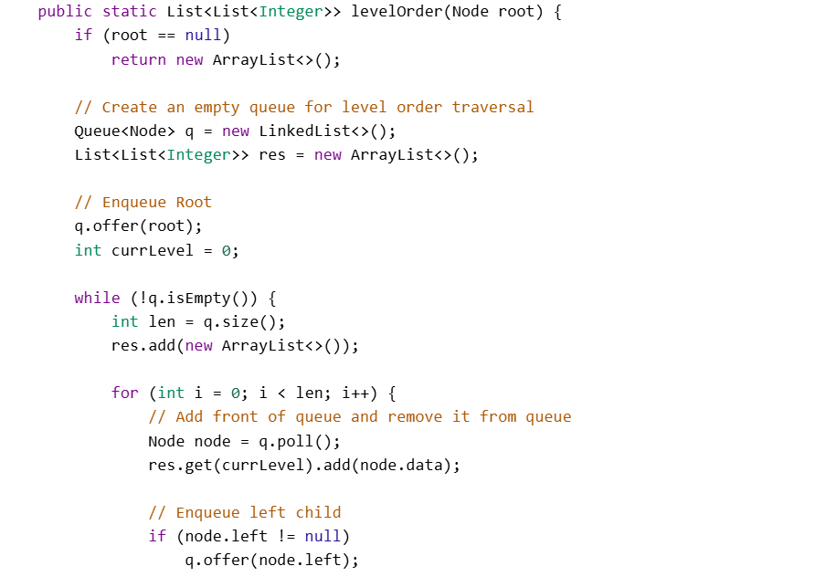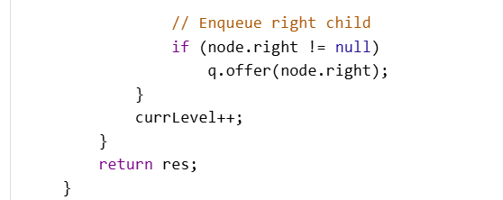

Python:
